**Mod 4: Critical Thinking**

Alex Mehler

CSU Global

CSC320-1

Farhad Bari

February 11, 2024

**Psuedocode:**

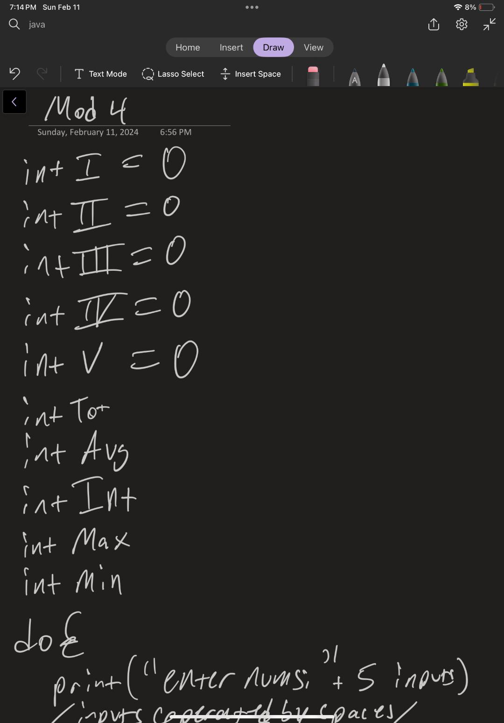

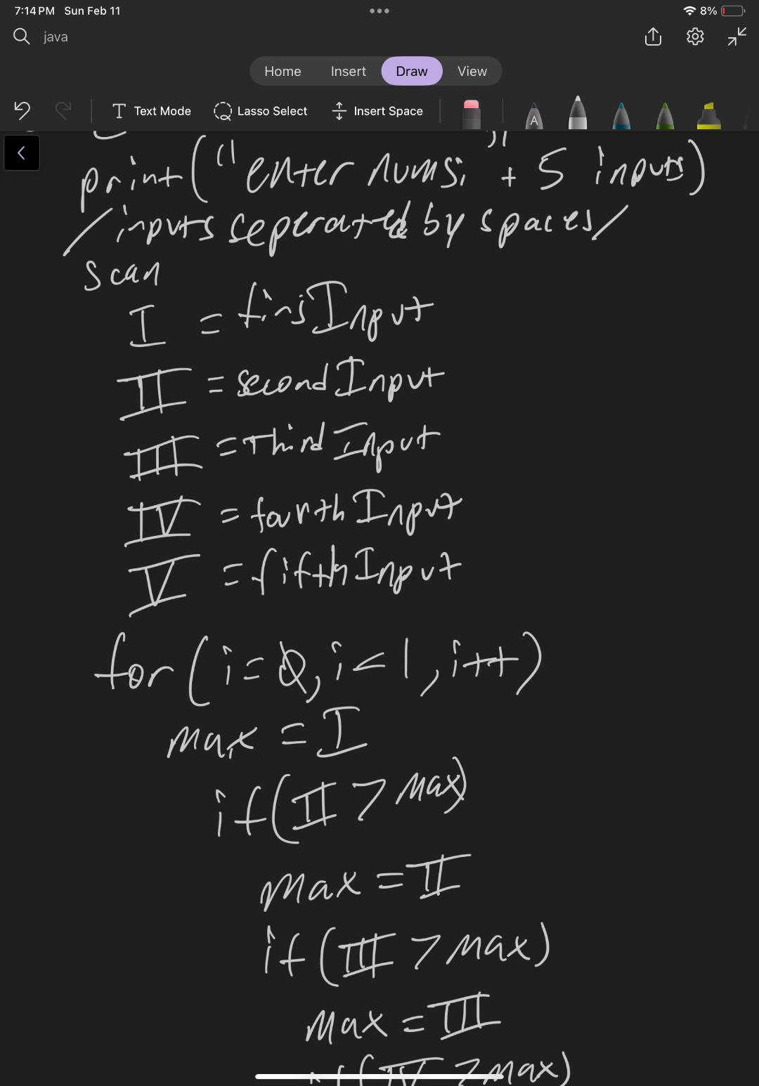

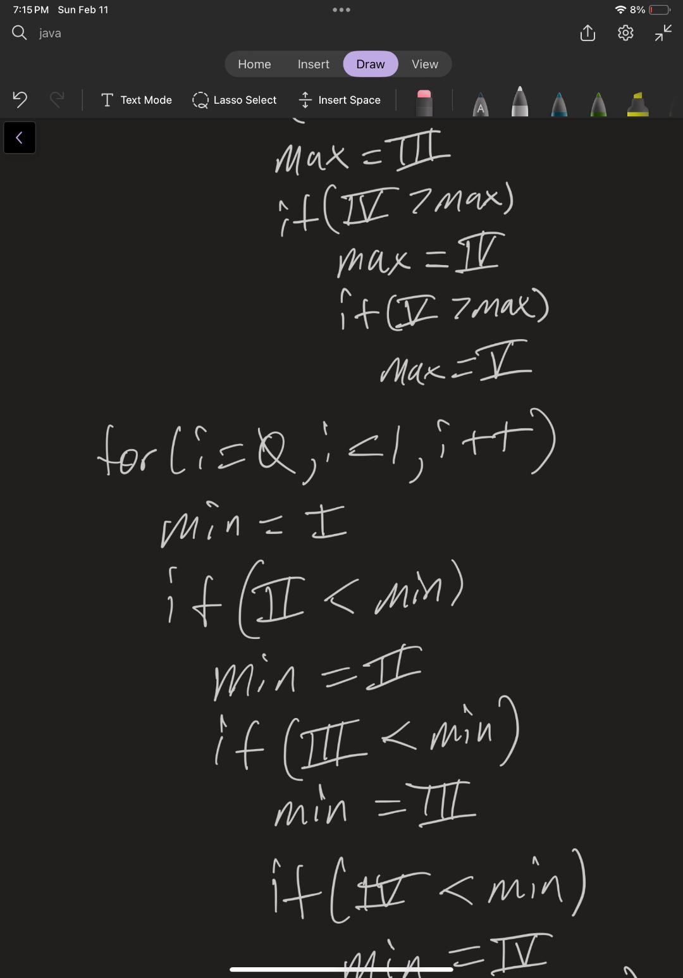

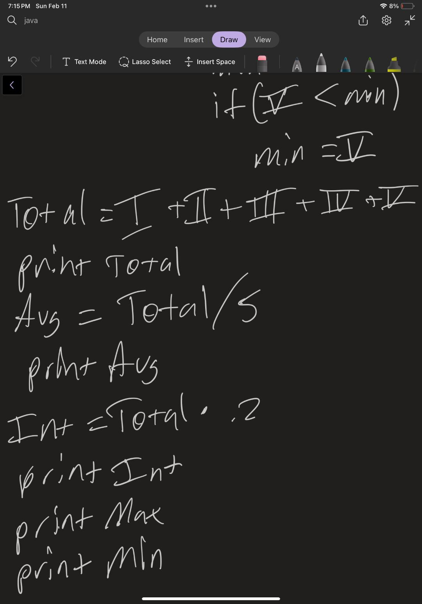

**Code Running:**

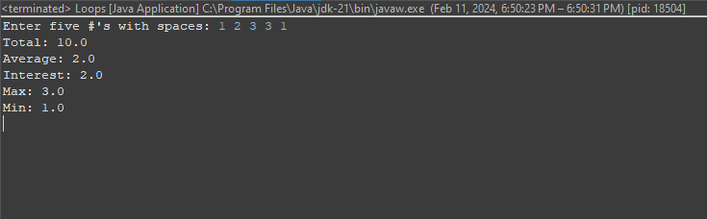

**Git:**

**Source Code:**

package Loops;

/**

* Loop practice, analyze 5 inputs

*/

/**

*

*/

import java.util.Scanner;

public class Loops {

public static void main(String[] args) {

double inputI = 0;

double inputII = 0;

double inputIII = 0;

double inputIV = 0;

double inputV = 0;

double Total;

double Avg;

double Interest;

double currentMin = 0;

double currentMax = 0;

do {

System.***out***.print("Enter five #'s with spaces: ");

try (Scanner input = new Scanner(System.***in***)) {

inputI = input.nextInt();

inputII = input.nextInt();

inputIII = input.nextInt();

inputIV = input.nextInt();

inputV = input.nextInt();

}

Total = inputI + inputII + inputIII + inputIV + inputV;

Avg = Total / 5;

Interest = Total * .2;

for (int i = 0; i < 1; i++) {

if (inputI >= currentMax) {

currentMax = inputI;

if (inputII >= currentMax) {

currentMax = inputII;

if (inputIII >= currentMax) {

currentMax = inputIII;

if (inputIV >= currentMax) {

currentMax = inputIV;

if (inputV >= currentMax) {

currentMax = inputV;

}

}

}

}

}

}

for (int i = 0; i < 1; i++) {

currentMin = inputI;

if (inputII <= currentMin) {

currentMin = inputII;

if (inputIII <= currentMin) {

currentMin = inputIII;

if (inputIV <= currentMin) {

currentMin = inputIV;

if (inputV <= currentMin) {

currentMin = inputV;

}

}

}

}

}

}

while (inputI == 0 || inputII == 0 || inputIII == 0 || inputIV == 0 || inputV == 0);

System.***out***.println("Total: " + Total);

System.***out***.println("Average: " + Avg);

System.***out***.println("Interest: " + Interest);

System.***out***.println("Max: " + currentMax);

System.***out***.println("Min: " + currentMin);

}

}